**Scope:**

One of the most common problems I have, and one that many people seem to have, judging by the number of memes floating around about the subject, is my inability to remember which username and password is associated with which application. It certainly would be nice if there were standardized/uniformed ways for us to log into all our accounts, whether they be to access our finances, to shop online, or to watch our favorite streaming service. Unfortunately, these different applications often require a different form of username/password credentials, and often the username that we have used on past accounts is somehow taken by someone else, no matter how unique it may be. Either that or we are prompted to enter an email address and a password, so we must try to remember which of our many email accounts, each with various passwords over the past few years, we are to use. Often, we are locked out of our account and forced to create a new password or fetch our existing credentials, which is not very cumbersome in and of itself, but there's is quite a bit of ambiguity involved, and quite a bit of accompanying frustration. It is my hope to create the framework for a user-friendly database that contains each/all of our login credentials for our macro-ing pleasure. Is this a lifechanging application? By all means, it is not. Would it be useful and alleviate some of the stresses of daily routine, whether it be personal or professional? I think, yes. I've used a system like this on my desktop before, but never for my mobile device, so I thought that it would be interesting to see if I could blend the framework for a multifunctional/multidevice system. Because there is highly sensitive data, potentially, there needs to be layers of security that protect personal identification information from getting out, and the relationships need to be mapped in a way that will eliminate any potential mismatch of consumer data. For this project, my application/storage system will be recognized as 'my program'.

**Conceptual Model:**

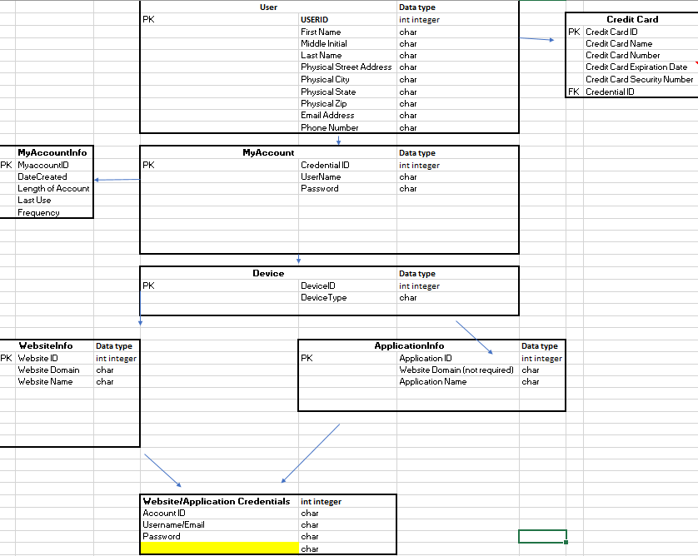

**Preliminary Glossary:**

|  |  |  |  |
| --- | --- | --- | --- |
| Attributes | | | |
| Entity | Attribute | Definition | Example |
| User | USERID | Unique Identifier (PK) | 1 |
| User | First Name | User's forename | John |
| User | Middle Initial | User's middle initial(s) | D |
| User | Last Name | User's surname | Doe |
| User | Physical Street Address | User's Physical Street Address | 1111 E Park Avenue |
| User | Physical City | User's Physical City | NY |
| User | Physical State | User's Physical State | NY |
| User | Physical Zip | User's Physical Zip | 51654 |
| User | Email Address | User's Main Email Address | [John.Doe@Gmail.com](mailto:John.Doe@Gmail.com) |
| User | Phone Number | User's Phone Number | 4808888888 |
| User | Date of Birth | User's Date of Birth | 8/4/1957 |
|  |  |  |  |
| Website | Website ID | Unique Identifier (PK) | 1 |
| Website | Website Domain | Website Domain | amazon.com |
| Website | Website Name | Website Name | amazon |
| Website | Platform Type (app, wap) | Platform Type | Website |
|  |  |  |  |
| Application | Application ID | Application ID | 1 |
| Application | Website Domain (not required) | Website Domain (not required) | chase.com |
| Application | Application Name | Application Name | chase |
| Application | Platform Type (app, wap) | Platform Type (app, wap) | application |
|  |  |  |  |
| Account | Account ID | Account ID | 1 |
| Account | Username | Username | Jdoe |
| Account | Password | Password | 123456 |
| Account | User Device Type | User Device Type | Mobile |
|  |  |  |  |
|  |  |  |  |
| Mycredentials | Credential ID | Credential ID | 1 |
| Mycredentials | UserName | UserName | Jdoe |
| Mycredentials | Password | Password | Jdoe123 |
| Mycredentials | Email Address | Email Address | [John.Doe@Gmail.com](mailto:John.Doe@Gmail.com) |
| Mycredentials | Date Created | Date Created | 7/29/2017 |
| Mycredentials | Length of Account | Length of Account ((Current Date - Date Created)/30) | 1 |
|  |  |  |  |
| Credit Card | Credit Card ID | Credit Card ID | 1 |
| Credit Card | Credit Card Name | Credit Card Name | John Doe |
| Credit Card | Credit Card Number | Credit Card Number | 8.88888880000000E+07 |
| Credit Card | Credit Card Expiration Data | Credit Card Expiration Data | 6.19 |
| Credit Card | Credit Card Security Number | Credit Card Security Number | 123 |
|  |  |  |  |
| Purchase History | Purchase History ID | Purchase History ID | 1 |
| Purchase History | Item Number | Item Number | 5 |
| Purchase History | Price | Price | 9.99 |
| Purchase History | Purchase Date | Purchase Date | 8/4/2017 |

**Normalized Logical Model Vizio:**

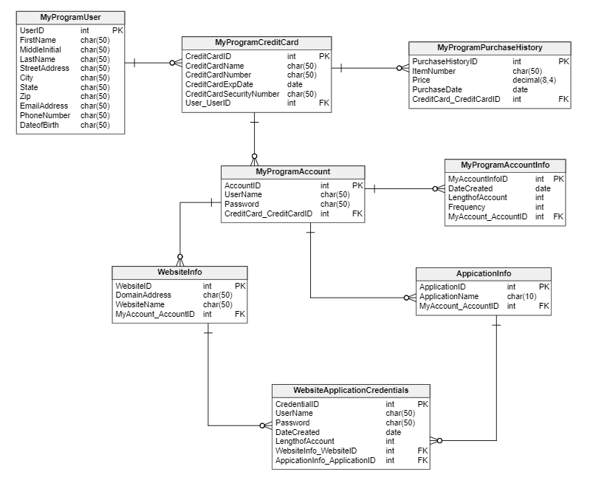

|  |
| --- |
| **Flow of the Diagram** |
| Modeled after the conceptualized user flow of my program. |
| User Flows to Credit Card. |
| Credit Card Flows to Purchase Order History. |
|  |
| User flows to myaccount, which is the form fill, of sorts, to create an account on my program |
| myaccount flwos to myaccount info, which contains metadata on the myaccount entity. |
|  |
| myaccount flows to device. |
| Device flows into both websiteinfo and applicationinfo. |
| These are the user's individual accounts on third party domains/applications, and this is the data that will be saved and macroed. websiteinfo and applicationinfo flow into website.applicationCredentials. |